- Installing gdal-filegdb: OGR FileGDB Driver
QGIS 3 – ESRI File Geodatabase
Installing gdal-filegdb: OGR FileGDB Driver with OSGeo4W Installer
As of 13 January 2022, version 1.0
For GDAL documentation on FileGDB driver click here.
Close QGIS software on your computer and go to Start Menu → Programs → OSGeo4W and Click Setup and choose Advanced Install.

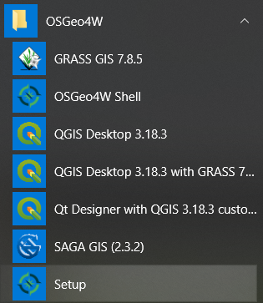
Click Setup and choose Advanced Install
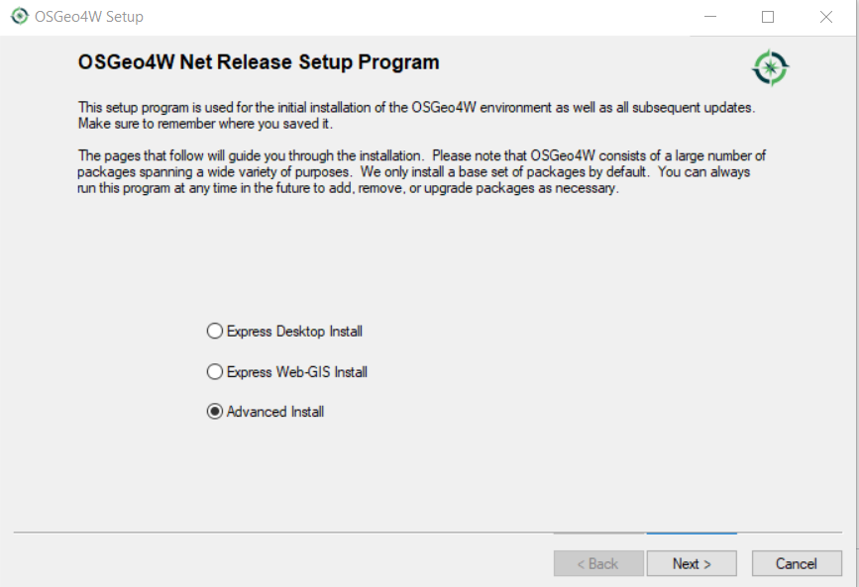
When prompted, choose Install from Internet and Direct Connection. Select download.osgeo.org as your download site.
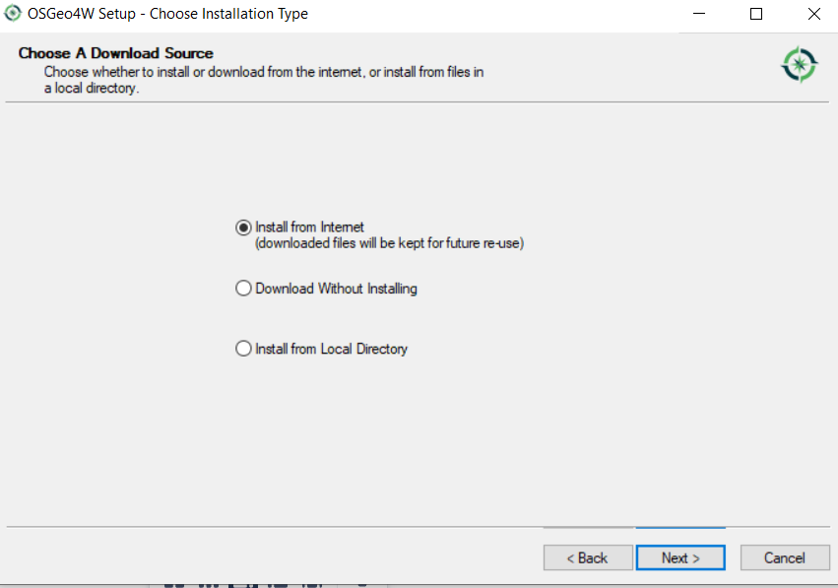
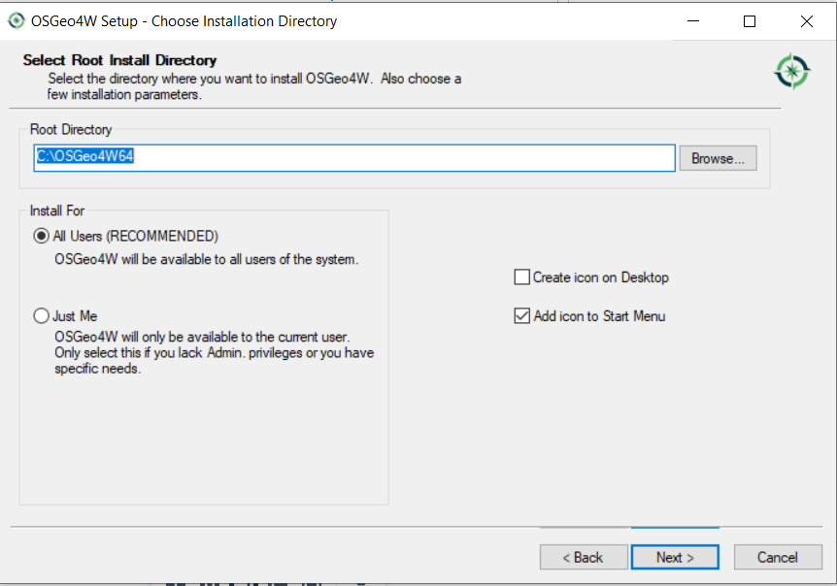
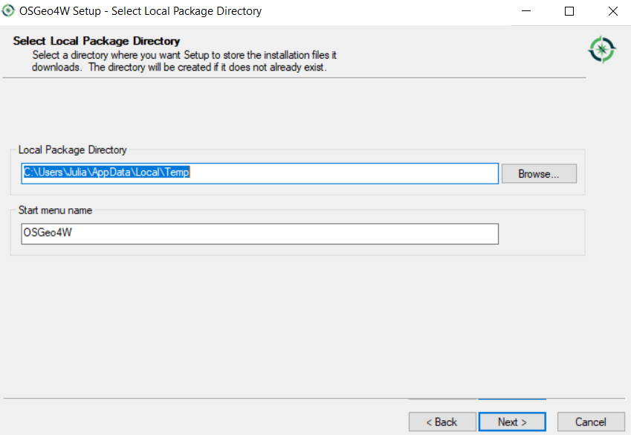
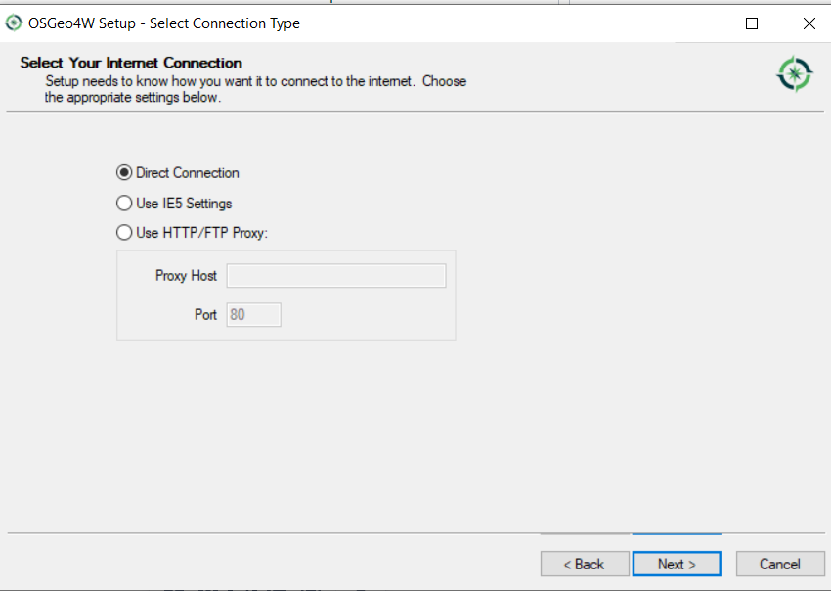
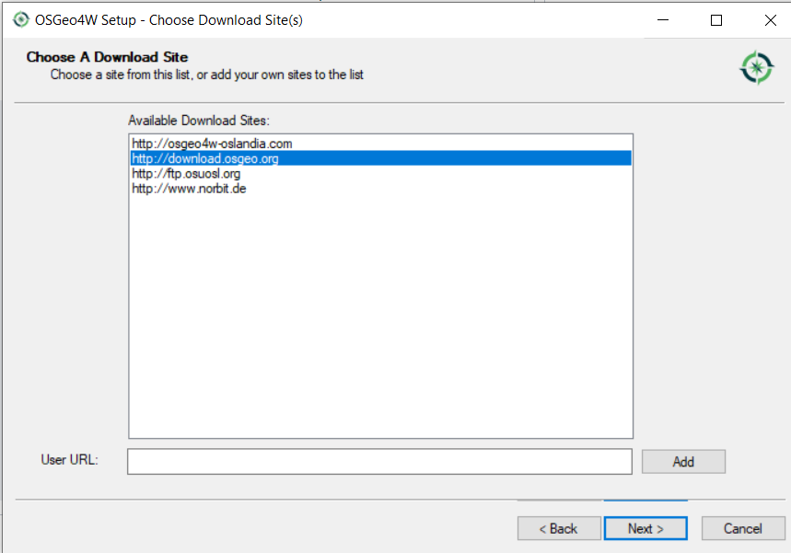
Click “+” to expand Libs, after expansion, go to gdal-filegdb: OGR FileGDB Driver under the last column of “Package”.

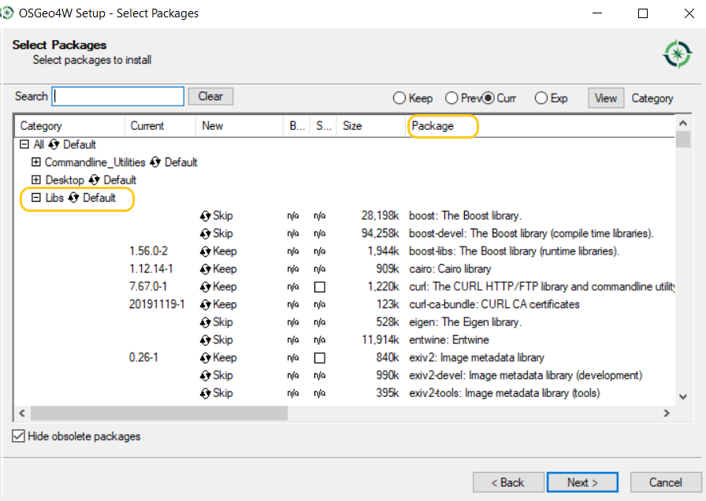
For gdal-filegdb: OGR FileGDB Driver, keep clicking the “New” column area and the value will rotate between Keep, Reinstall, new and/or old version number of FileGDB drive.

The newest version 3.1.4-3 is chosen and click Next to install FileGDB Driver for the first time.
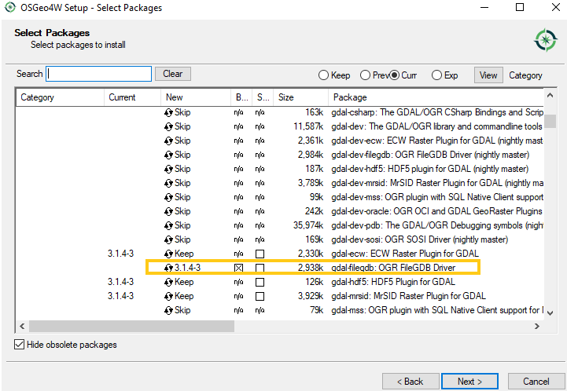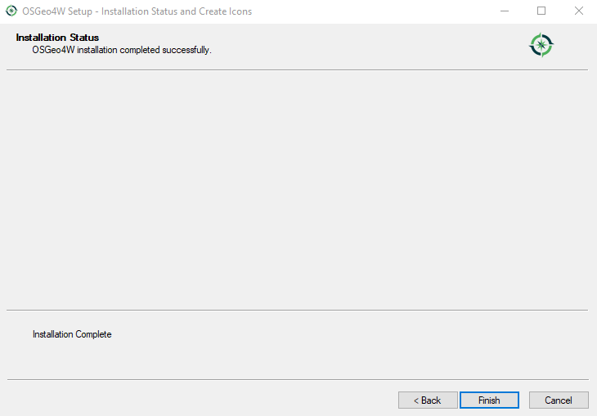

After FileGDB Driver is installed successfully, to open a file geodatabase with the intent to edit and write it in QGIS, open Data Source Manager – Vector select Source Type as Directory, and the Drive Type as ESRI FileGDB. and select the file geodatabase you want to open click Add to bring the file geodatabase into QGIS.
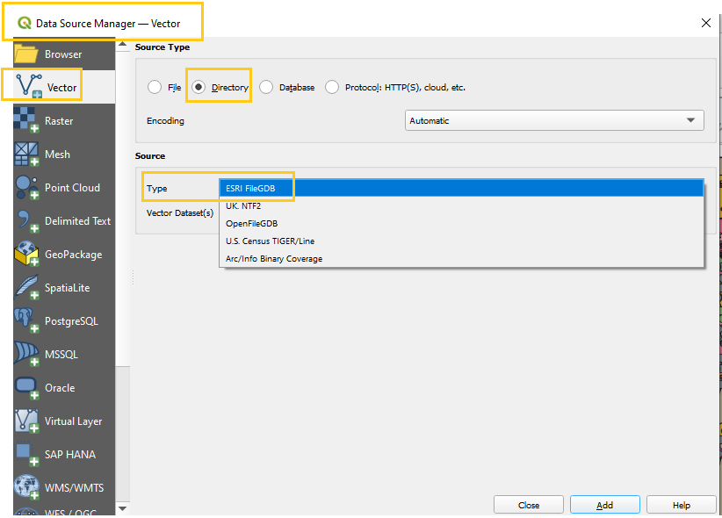

Select the file geodatabase you want to open click Add to bring the file geodatabase into QGIS
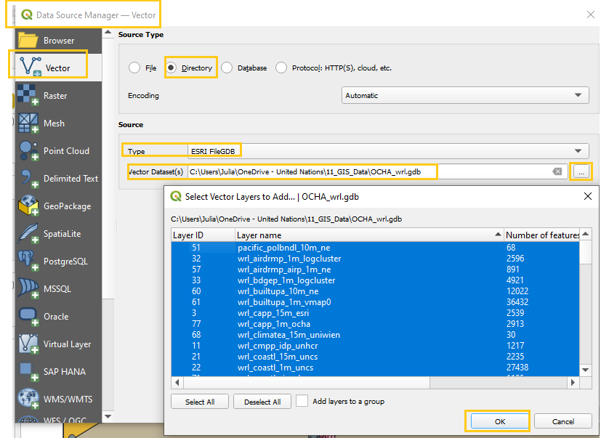
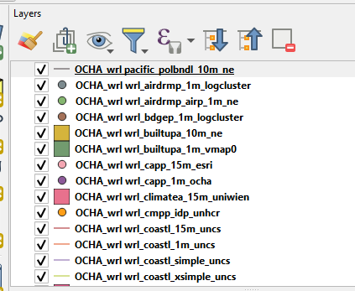
After a file geodatabase is brought into QGIS, regardless of which driver is used, you can always convert it to a shapefile (or other formats) by right clicking the file, then select Export → Save Features As … .
