QGIS
How to install QGIS on Windows
As of 6 Jan 2022 - Version 1.0
- Installing QGIS on Windows
On Windows, there are two different options for installing QGIS. These are the OSGeo4W (Network Installer) and the QGIS Standalone Installer.
You can download QGIS from here using the option best suited for you: https://www.qgis.org/en/site/forusers/download.html#
  - The OSGeo4W Network Installer
The OSGeo4W installer is a small, flexible installation tool that makes it possible to download and install QGIS and many more OSGeo tools with all their dependencies. The main advantage is that it makes updating QGIS and its dependencies very easy.
Download the version that matches your operating system and keep it. In the future, whenever you want to change or update your system, just run it again.
  - The QGIS Standalone Installer
The QGIS Standalone Installer is one file to download, it contains a QGIS release, the Geographic Resources Analysis Support System (GRASS) GIS, and the System for Automated Geoscientific Analyses (SAGA) GIS in one package. For a beginning, this is the easiest installation option.
- Installing QGIS using the OSGeo4W Installer
Using the OSGeo4W installer is a convenient way to install QGIS and a host of other open-source GIS tools.
  - Latest QGIS release
    - Express Install
Start by double-clicking on OSGeo4W executable. This will lead you to the following screenshot:
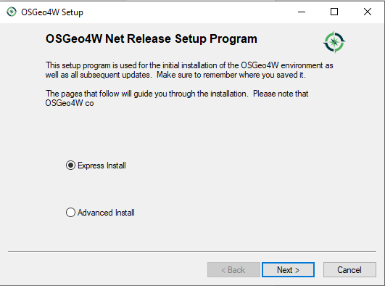
In the Installer choose Express Install and select QGIS to install the latest release or QGIS LTR to install long term release.
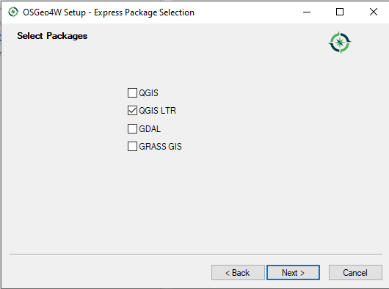
The express installations have several optional packages including non-free software.
      - Setting the Express Package selection 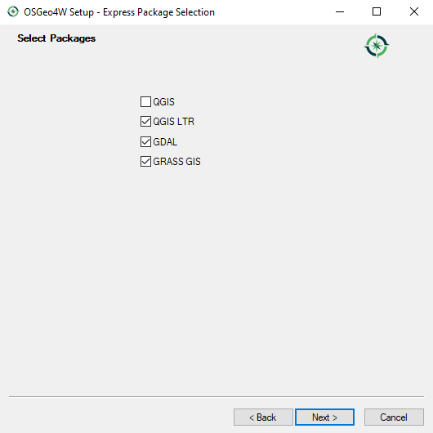
Choose which package to install and click on the Next button. This will set off the download process. Progress will be displayed as each component is downloaded. Having these installed, will provide you with more tools to perform Geospatial analysis.
You should see OSGeo4W in your programs menu along with all the other stalled software.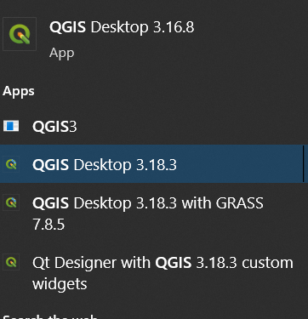
It is possible to have multiple versions of QGIS installed on Windows. This may mean that you could have QGIS 2 and QGIS 3 running on the same machine. Remember QGIS 3 projects will not open in QGIS 2. You may need to have two versions installed if you are reliant on a plugin that is no longer supported or has as yet to be ported to QGIS 3.
    - Advanced Installer
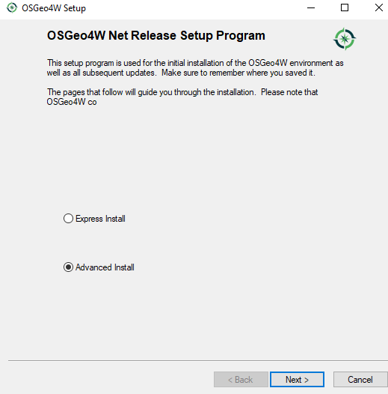
To specify version and avoid optional packages, use the Advanced Install. The Advanced Install is useful if you want to customize your installation or choose your installation version or perhaps install the development version of QGIS
Step through the installation wizard. When you get to the Select Packages, choose the version you require. Choose qgis and/or qgis-ltr in the Desktop section.
In the following screenshot I have selected the 3.22.2-1 QGIS latest release and 3.16.15-1 QGIS long term release.
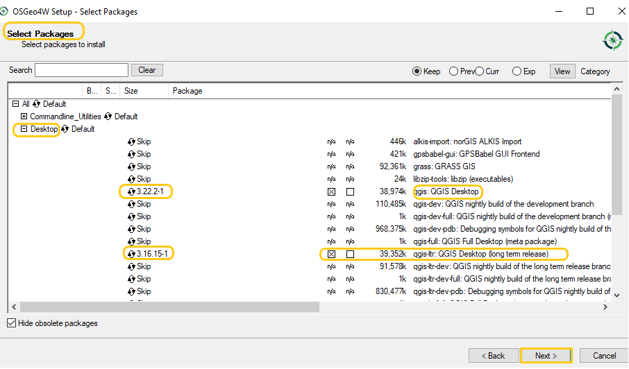
You can select other packages if required. Once you have chosen the software, click on the Next button. Step through the wizard by accepting the defaults and the installation will begin.

