QGIS 3
How to load maps templates
5 Jan 2022

QGIS map templates
The A4 Landscape and A4 Portrait map templates: 2022_OCHA_A4_Landscape_QGIS_3.16_Template.qpt and 2022_OCHA_A4_Portrait_QGIS_3.16_Template.qpt can be found here. (Load templates to IM toolbox + share with brand portal)
Below you will find instructions on how to load the templates, for you to use in QGIS. Alternatively, you can also watch this short video.

Installing QGIS templates
Download the templates
Find the repository where you need to place the templates
In QGIS go to Project > and open the Layout Manager.
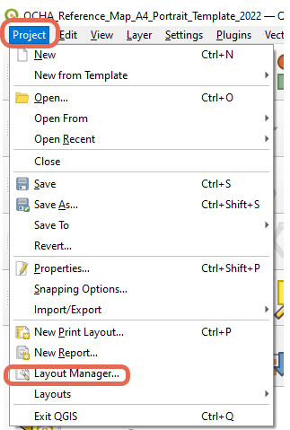
In the Layout Manager Click on User. This will open the repository where you will need to copy/paste the templates. 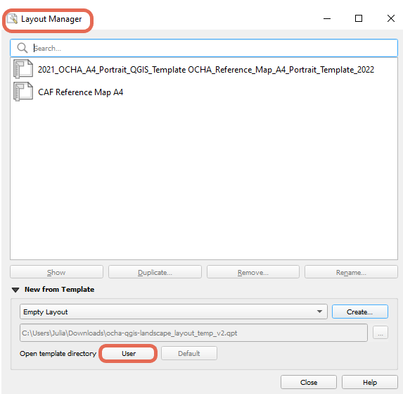
Depending on where you have installed QGIS your path might look different.
C:\Users\XXXX\AppData\Roaming\QGIS\QGIS3\profiles\default\composer_templates
Copy/paste the templates
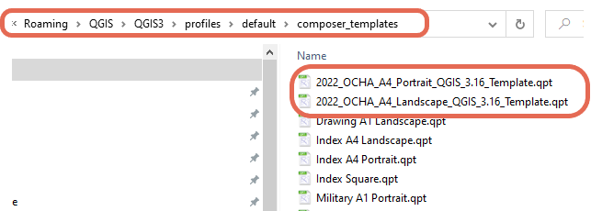
Once you have copied the templates you will be able to use them in QGIS.

Importing OCHA map style
You will need to download the 2022_OCHA_QGIS_ReferenceMap_Style.xml file.
For your reference you can find more in-depth documentation on the Style Manager here.
- Download xml Style file
In QGIS open the Style Manager
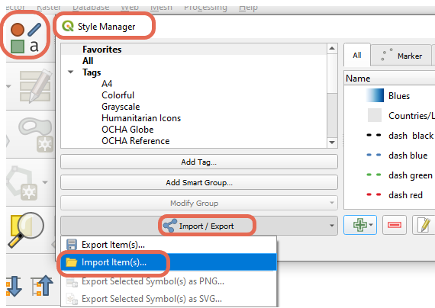
Click on Import/Export and Select Import Items(s)
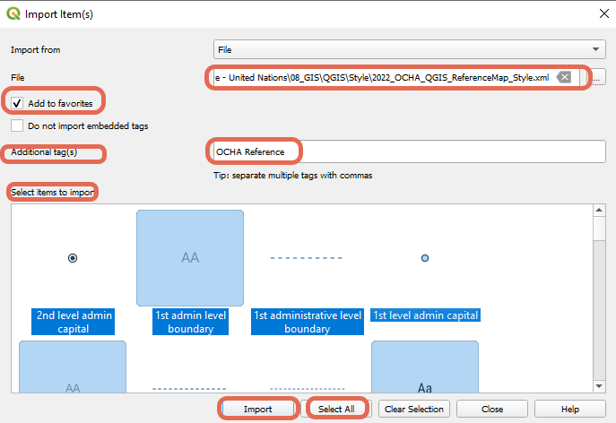
Import style
Navigate to where you have downloaded the 2022_OCHA_QGIS_ReferenceMap_Style.xml file.
You can check Add to favorites and add additional tags.
Either chose the symbols you want to import or Click Select All and Import.
Find imported style
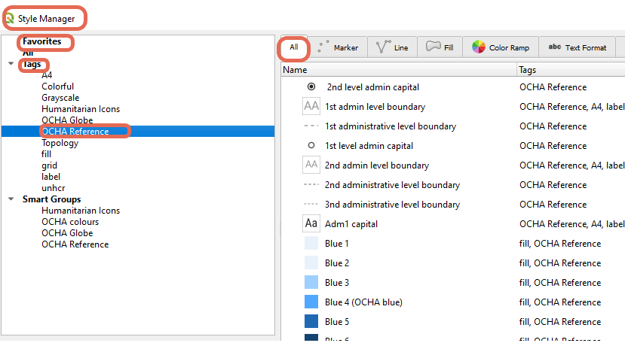

Importing ArcGIS style files with SLYR plugin
Here are some resources that will guide you on how to import ArcGIS style files (.style) into QGIS.
Make sure to check your imported symbology, the symbols & colors might not come perfectly across, or some do not come across at all.
- From Open.gis.lab: Converting ESRI Styles to QGIS XML Using SLYR: https://opengislab.com/blog/2019/3/16/converting-esri-styles-to-qgis-styles-using-slyr
- YouTube video on How to import Esri Style with SLYR https://www.youtube.com/watch?v=3_J2j68xgNo

Importing custom SVG symbols to QGIS
Detailed resources at: QGIS User Guide: 12.2.2.2.2 Marker Symbols
- Point your SVG path
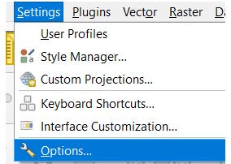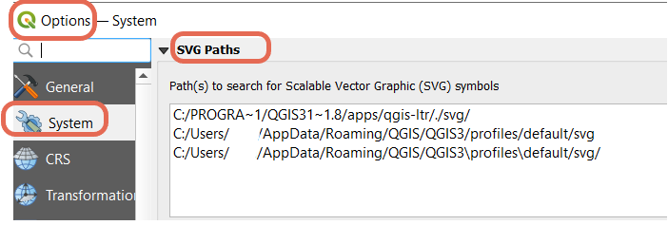
Under SVG Paths, make sure that paths are listed.
Copy the SGV icons, or SVG folder into one of these locations
C:\Users\XXX\AppData\Roaming\QGIS\QGIS3\profiles\default
C:\Program Files\QGIS 3.16.8\apps\qgis-ltr\svg
Depending on your installation path, this might be different.
As an example, we will be using the custom North Arrow used in OCHA Reference Maps.
SVG of North Arrow has been copied to C:\Program Files\QGIS 3.16.8\apps\qgis-ltr\svg\arrows
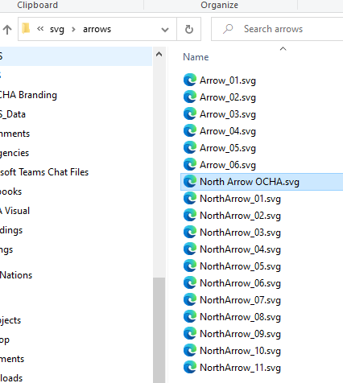
- Add symbol to Style Manager

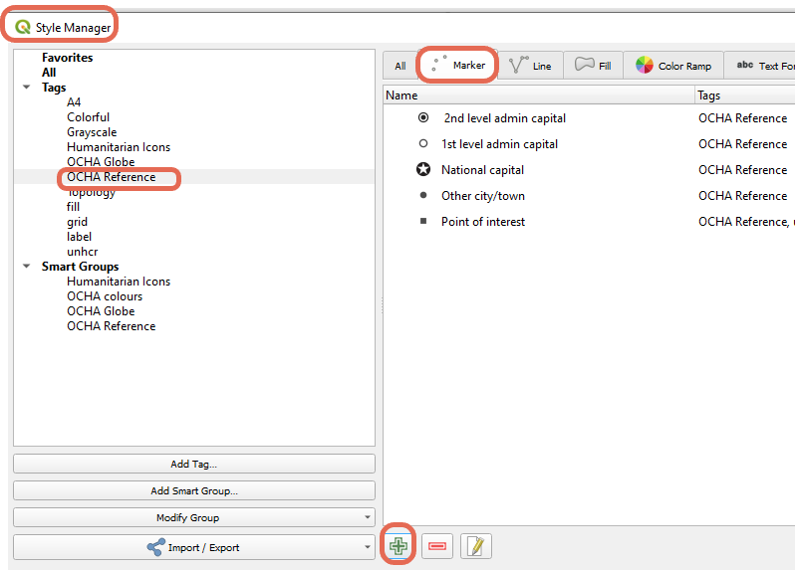
- In the Style Manager choose where you want to import the new symbol to (one particular group, tag, favorites etc). Here we will use the tag OCHA Reference.
- Under Marker click , this will open the following window.
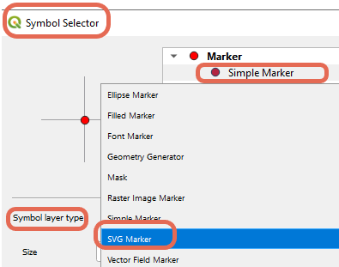
- Change the Symbol layer type to SGV Marker
- You can adjust size, unit etc
- Under SVG browser, navigate to the folder where the new SVG symbol is.
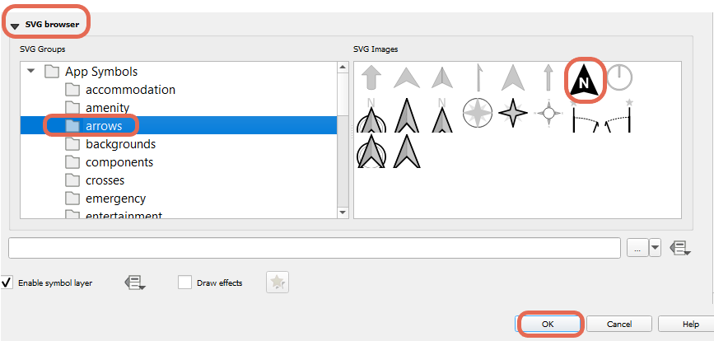
- Select the SVG Image in the right-hand side pane and click OK.
- Then Save the New Symbol.
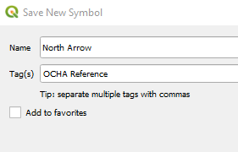
- Give the new symbol a Name
- Fill in the Tag(s)
- Additionally, you can check the Add to favorites box
- You will now be able to find the new symbol where you saved it.