- Loading data
QGIS 3
How to Load Data
As of 13 January 2022 - Version 1.0
Loading data into QGIS can be done in several ways. Here are the most common ways:
- You can drag data directly from a folder (Windows OS) straight into the map
- You can drag data from the Browser panel into the map
- You can click Layer >Add Layer and choose what type of layer to add to the map
- You can click Layer > Data Source Manager
  - Layer > Add Layer
In the following screenshot, we are choosing to load Add Vector Layer, which can also be done using the Ctrl + Shift + V shortcut:
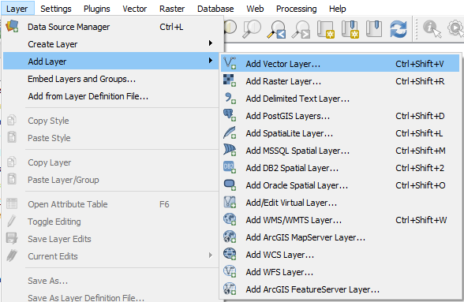
This screenshot gives you an idea of all the different data types that QGIS can consume.
  - QGIS Data Source Manager
To open the Data source Manager, either click on in the Data Source Manager Toolbar or click Layer > Data Source Manager or Ctrl + L.
The Data Source Manager is a really nice way of adding data to your map. You can add files one by one, add multiple files, or add different file types at the same time.
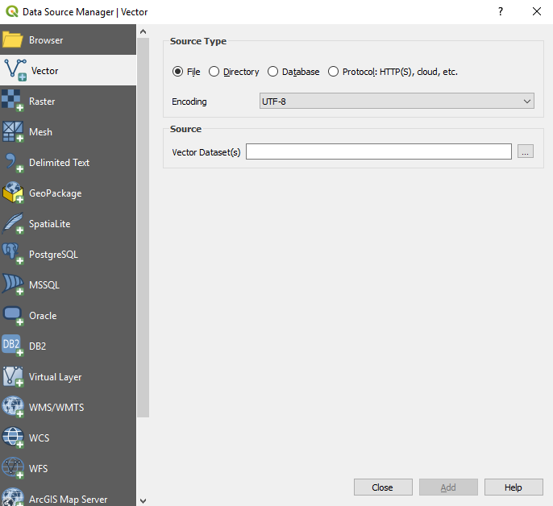

  - Adding data from a File GDB
