QGIS
How to Create a GeoPackage with QGIS 3.16
As of 10Jan 2022 - Version 1.0
- Creating a GeoPackage in QGIS
GeoPackage is a standard OGC data package that can store different types of spatial data types such as points, polylines and polygons. Several layers can be saved in just one GeoPackage (.gpkg ) file. It is an excellent way to store and organize spatial data with QGIS.
When you save your spatial files to GeoPackage format you can easily find them without having to browse and to dig in all your records.
Using GeoPackage to store spatial data has many advantages:
- Data will be placed in a centralized location.
- Reduce cluttering that occurs when dealing with multiple files.
- Easier to transfer huge amounts of layers in a single GeoPackage
  - Creating an empty GeoPackage
Go to Layer > Create a layer > New GeoPackage Layer
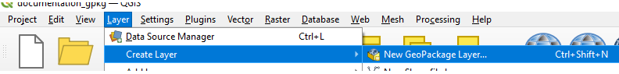
Type the name of the new GeoPackage, give a name to the table and possibly select a geometry in the list. If you expect to import existing layers in your Geopackage, you can click OK. 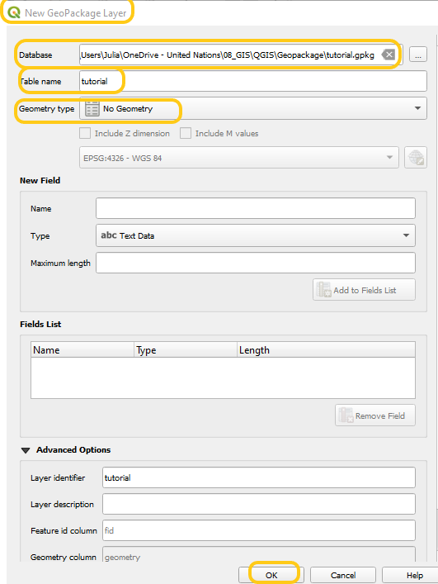
Your GeoPackage will be created and almost empty; you will have this empty table but with the possibility of erasing it at any time.
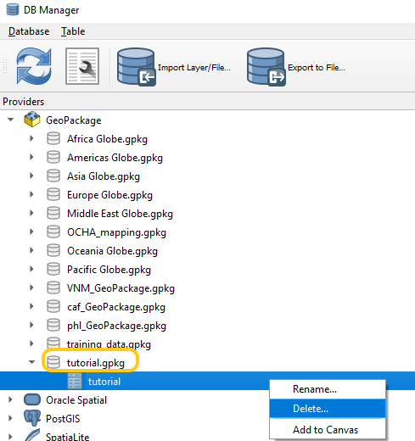
If, on the other hand, you want to start creating a true working layer, you will use the block New field from the window to define your table columns.
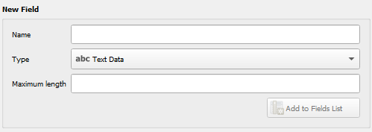

- Connecting to GeoPackages
To use GeoPackages in QGIS you must connect to them.
You can establish a connection using either the Browser panel or the DB Manager.
  - New Connection using the Browser Panel
- In the Browser Panel, Right click on GeoPackage > New Connection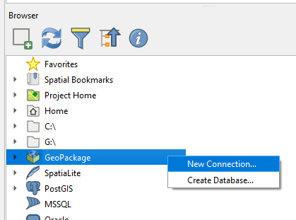
- Choose the GeoPackage file you want to connect to and click Open.
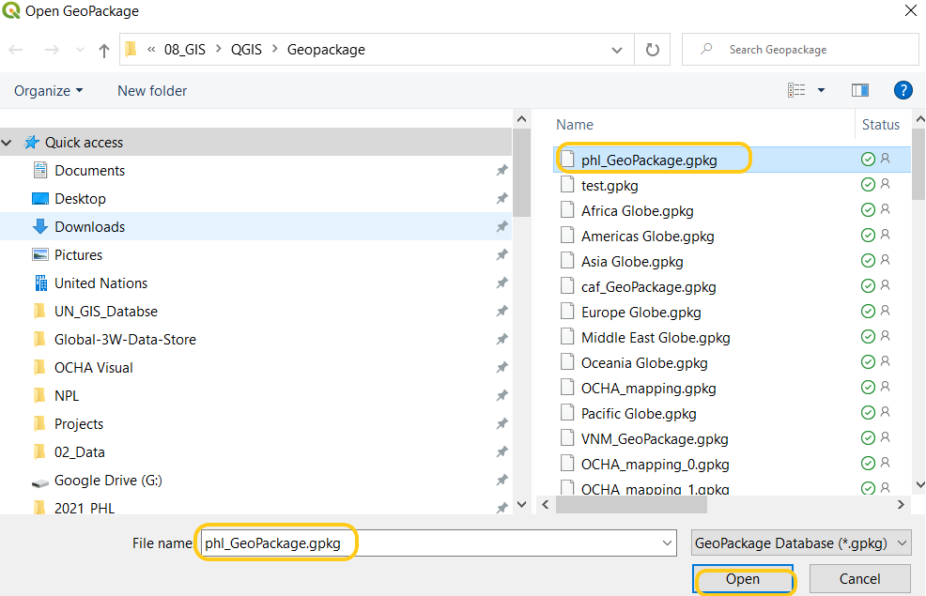
- The new database appears in the Browser as follows.
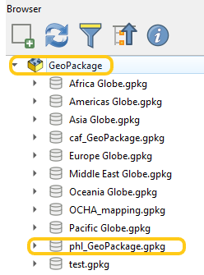
  - New Connection using the DB Manager
- To open go to Database> DB Manager.
- Under Providers, right click on GeoPackage> New Connection
- 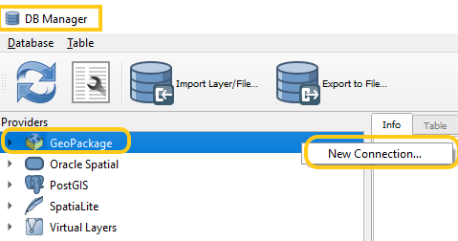
- Browse to where the GeoPackage is saved and select GeoPacakge you want to connect to.
- 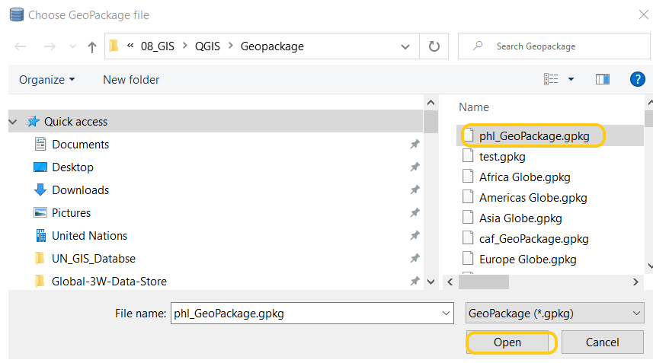
- The new GeoPackage will appear in the DB Manager under GeoPackage
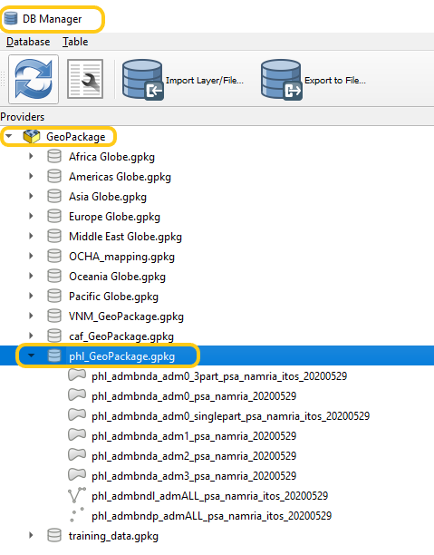

- How to add data to a GeoPackage
  - Creating a new GeoPackage layer
To see how to create a new GeoPackage layer you can refer to the QGIS Documentation.
  - Using the Processing tools (Database>Package layers)
- Add the spatial layers to the Layers Panel that are to be feature classes in the GeoPackage.
- 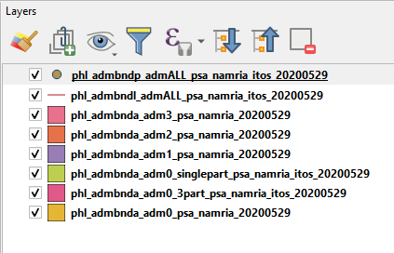
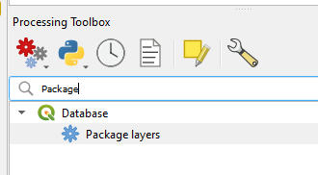
- Click Processing> Toolbox and search for Package layers which can be found under Database
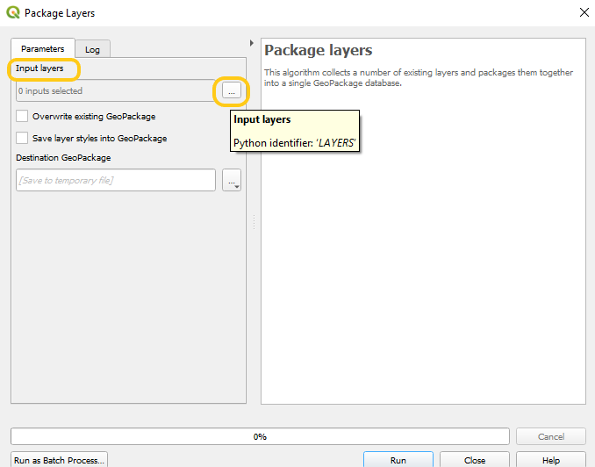
- Double-click the Package layers option. The Package layers window will appear. Click the … next to Input layers field.
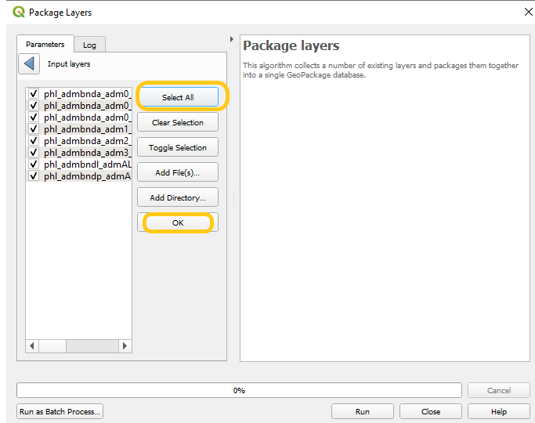
- And select the layers to add to the GeoPackage file. Click Ok.

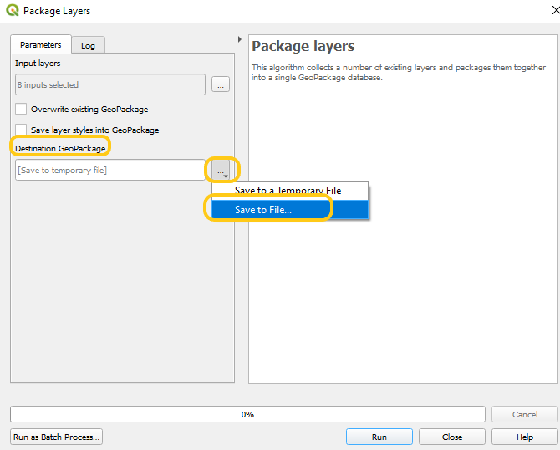
- Click the ... > Save to File ... button next to the Destination GeoPackage field.
- Browse to the location to save the GeoPackage file. Give the GeoPackage file an appropriate name. Click Save.
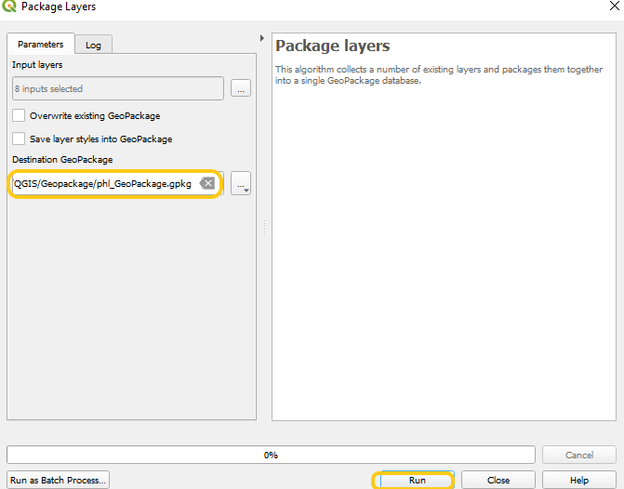
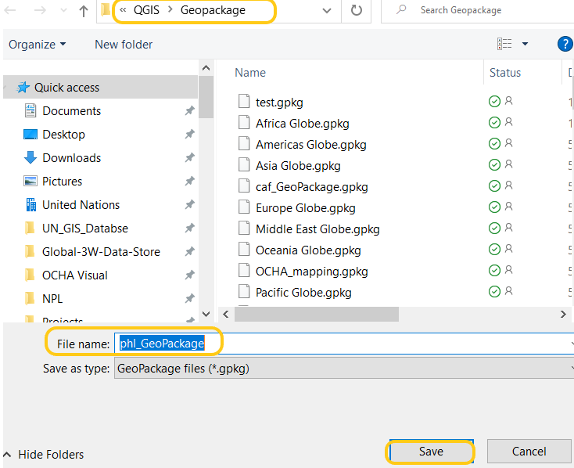
- Click Run.

  - Saving from an existing layer
You can export to a GeoPackage file an already existing layer.
- Select layer in Layers Panel, Right Click > Export > Save Feature As
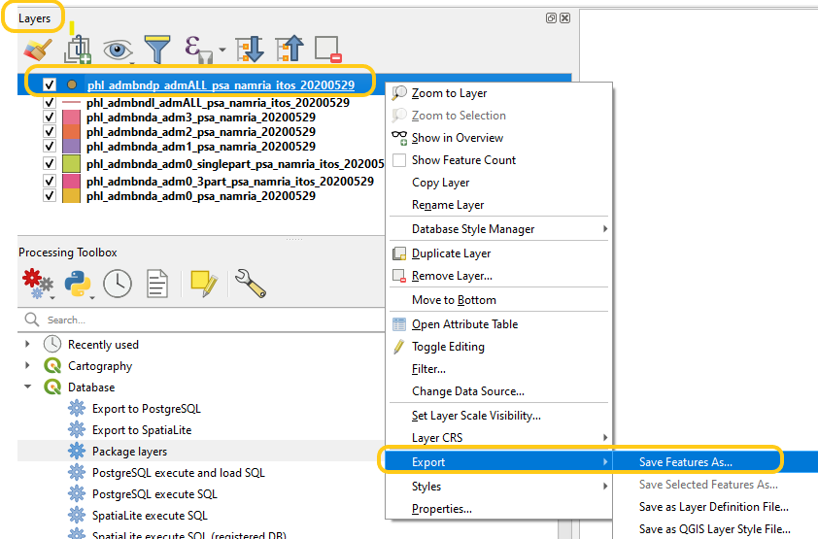
- In the Save Vector Layer as window, under Format select GeoPackage
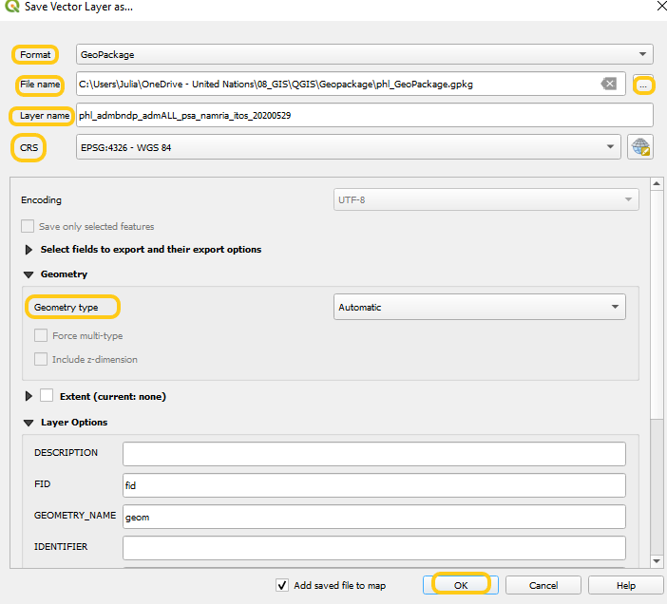
- In File Name, click and point to your GeoPackage file.
- Fill in the necessary fields and click OK. The layer is imported to your GeoPackage.
  - Using the DB Manager
The DB Manager allows you to totally manage your data and databases. To open go to Database> DB Manager.
- In the panel Data providers select the GeoPackage to which you want to add the layer
- Click Import Layer/File
- Next to Input, choose the layer that you want to add
- Check the Source SRID and Target SRID boxes
- Check the Create a spatial index box if you in want one.
- Click OK.
