QGIS 3
Creating Custom Projection – UNOCHA Globes
As of 14 January 2022, version 1.0
- UNOCHA Globes
UNOCHA Globes are based on the World_Vertical_Perpective Coordinate System (WKID:54049)

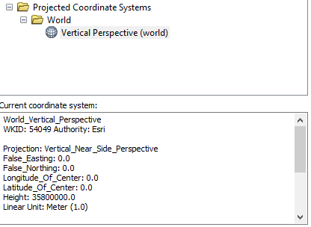
As of now, the only way I have found for this projection to work properly in QGIS is to:
- Build a GeoPackage for each Globe, saving layers projected, using specific World_Vertical_Perspective,
- Create custom projections in QGIS (as described below)
- Apply again Custom projection to layers.

Here is how the Africa Globe looks like when I bring in the already projected (World_Vertical_Perspective) layers.
The current CRS is EPSG: 4326
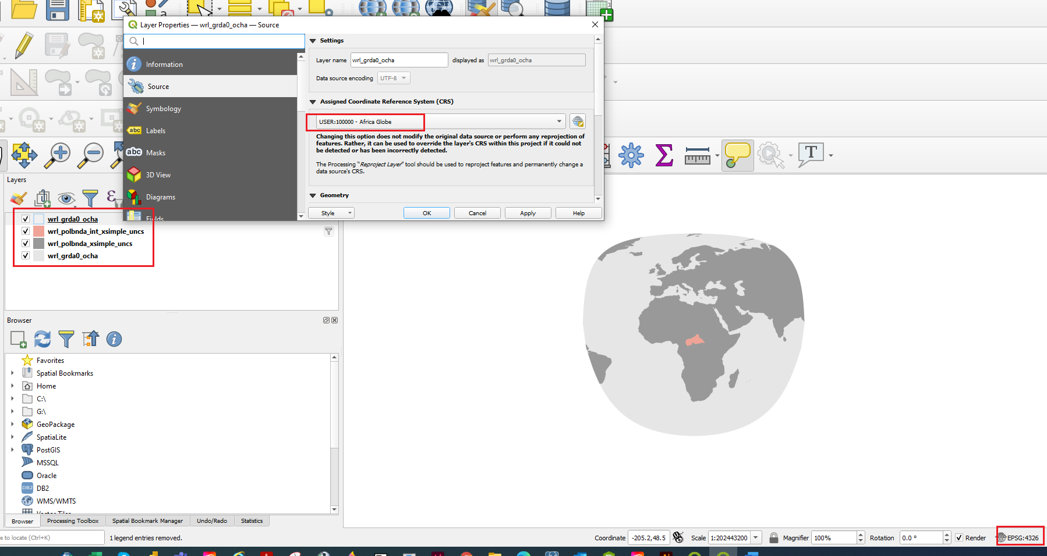

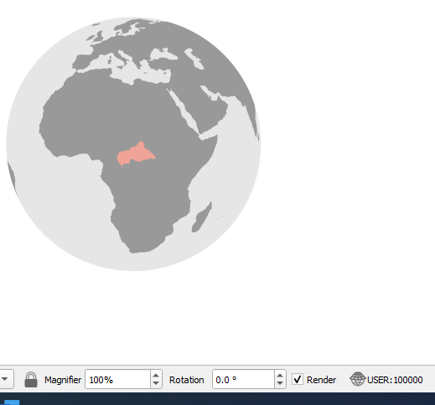
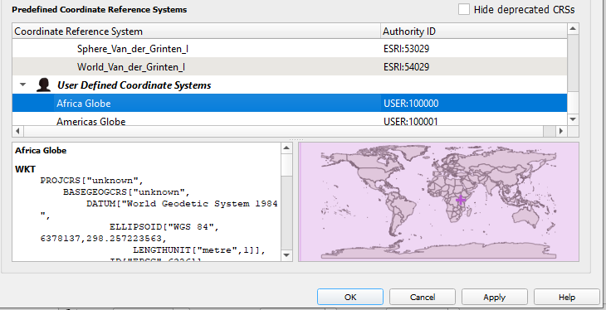
When I change the current CRS to the Custom Africa Globe that I created, the layers project correctly.

- Creating your own projections
Go to Settings> Custom Projections… and you will see this dialog.
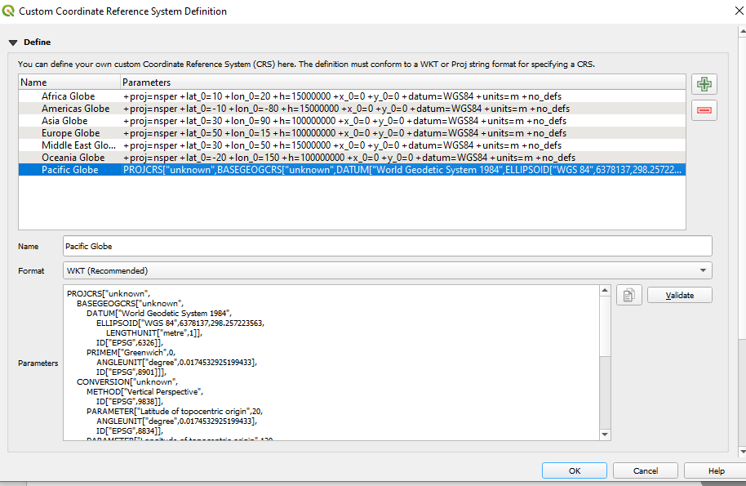

Click on 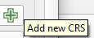 button to create a new projection.
- Africa Globe
Enter Africa Globe in Name field (or name of your choice).
In Format, select Proj String
Add the following String in Parameter field: +proj=nsper +lat_0=10 +lon_0=20 +h=15000000 +x_0=0 +y_0=0 +datum=WGS84 +units=m +no_defs
Click OK
This creates the custom projection:
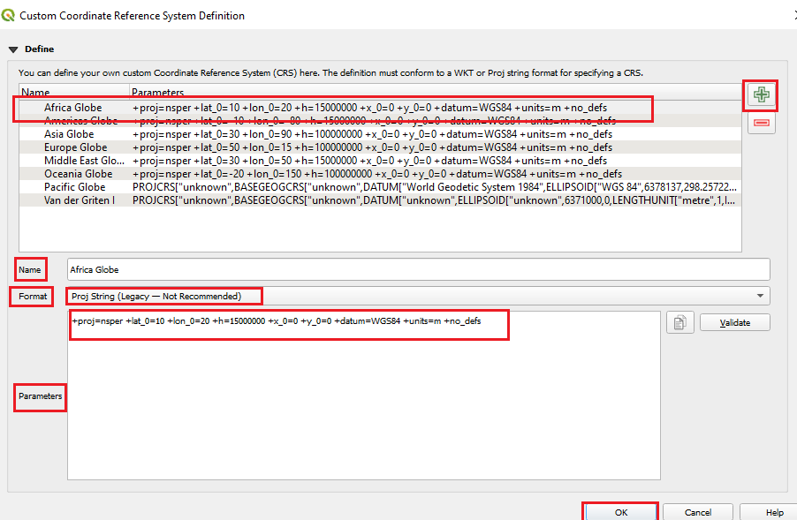
- Other Globes
To define other custom projections, go through the same steps as above. Give the custom projection a relevant name and paste in the Parameters window the following Proj Strings.
  - Americas Globe
+proj=nsper +lat_0=-10 +lon_0=-80 +h=15000000 +x_0=0 +y_0=0 +datum=WGS84 +units=m +no_defs
  - Asia Globe
+proj=nsper +lat_0=30 +lon_0=90 +h=100000000 +x_0=0 +y_0=0 +datum=WGS84 +units=m +no_defs
  - Europe Globe
+proj=nsper +lat_0=50 +lon_0=15 +h=100000000 +x_0=0 +y_0=0 +datum=WGS84 +units=m +no_defs
  - Middle East Globe
+proj=nsper +lat_0=30 +lon_0=50 +h=15000000 +x_0=0 +y_0=0 +datum=WGS84 +units=m +no_defs
  - Oceania Globe
+proj=nsper +lat_0=-20 +lon_0=150 +h=100000000 +x_0=0 +y_0=0 +datum=WGS84 +units=m +no_defs
  - Pacific Globe
+proj=nsper +lat_0=20 +lon_0=120 +h=100000000 +x_0=0 +y_0=0 +datum=WGS84 +units=m +no_defs +type=crs
- Applying Custom projection
- Click on the ^{Current CRS} button at the right of the status bar to change the project CRS
- Choose your newly defined projection (search for its name in the Filter field)
- On applying this projection, the map will be reprojected

