|  |  |
| --- | --- |
| Quick Reference Guide: ESRI Disaster Response Program  Requesting Emergency Assistance/ESRI License (as of July 2014) |  |

Purpose

This quick guide provides OCHA staff with information on how to request free ESRI license(s) for the duration of six months, managed under ESRI’s Disaster Response Program (DRP). ESRI supports organizations that are responding to disasters with software, data, imagery, project services, and technical support.

Scope

ESRI’s free license agreement under DRP may be utilized by OCHA in an instant where there is an Emergency Response Deployment of Information Management Officer(s) who is part of a Stand-by-Partner and Associate Surge Pool.

Focal Points and Roles

* **Field Information Services (FIS)**

The FIS Field Support team is responsible for providing support in requesting ESRI licenses under the DRP. They may also be called for support on the installation of the ArcGIS software on a standard OCHA computer/laptop.

|  |  |  |
| --- | --- | --- |
| Focal Point | E-mail / Extension | Role |
| [Janet O’Callaghan](https://ochanet.unocha.org/personal/mysites/Person.aspx?accountname=i%3A0%23.f|ldapmembershipocha|ocallaghan%40un.org) | [ocallaghan@un.org](mailto:ocallaghan@un.org) / 7-2013 | FIS Head of Field Support |
| [Patrick Hernusi](https://ochanet.unocha.org/personal/mysites/Person.aspx?accountname=i%3A0%23.f|ldapmembershipocha|hernusi%40un.org) | [hernusi@un.org](mailto:hernusi@un.org) / 7-1096 | ESRI Liaison/License requestor |
| [Kristina Mackinnon](https://ochanet.unocha.org/personal/mysites/Person.aspx?accountname=i%3A0%23.f|ldapmembershipocha|mackinnonk%40un.org) | [mackinnon@un.org](mailto:mackinnon@un.org) / 7-1196 | Backup ESRI Liaison |

* **Corporate Information Services (CIS)**

The CIS Service Desk team is responsible for providing a standard OCHA computer/laptop on which ESRI ArcGIS software must still be ordered separately and installed, as it is not part of standard software.

|  |  |  |
| --- | --- | --- |
| Focal Point | E-mail / Extension | Role |
| [Service Desk Team](https://ochanet.unocha.org/AS/Information_Technology_Services/Pages/default.aspx) | [servicedeskocha@un.org](mailto:servicedeskocha@un.org) | Handles all requests for new OCHA computer |
| [Yves-Marie Cilote](https://ochanet.unocha.org/personal/mysites/Person.aspx?accountname=i%3A0%23.f|ldapmembershipocha|cilote%40un.org) | [cilote@un.org](mailto:cilote@un.org) / 7-1965 | CIS Head of Client Services |
| [Michael Sullivan](https://ochanet.unocha.org/personal/mysites/Person.aspx?accountname=i%3A0%23.f|ldapmembershipocha|sullivan5%40un.org) | [sullivan5@un.org](mailto:sullivan5@un.org) / 7-1594 | Client Services Supervisor |

* **ESRI**

The ESRI Focal point listed below may be contacted upon requesting licenses under DRP.

|  |  |  |
| --- | --- | --- |
| Focal Point | E-mail | Role |
| ESRI Disaster Help Team | [disaster_help@esri.com](mailto:disaster_help@esri.com) | Handles requests submitted via ESRI Disaster Response Program |
| Tina Skousen | [tskousen@esri.com](mailto:tskousen@esri.com) | Domestic Manager/Customer Service |

Requesting Emergency Assistance from ESRI

Any Information Management Officer (or other OCHA staff) can make requests to ESRI Disaster Response Program, provided that the staff member has an ESRI Global Account (<https://accounts.esri.com/commonquestions>). To create an ESRI account, visit [ESRI accounts creation site](https://accounts.esri.com/signup?redirect_uri=https%3A%2F%2Fcustomers.esri.com%3Fevent%3Dportlet.dspTasks%26token%3D&failurl=https%3A%2F%2Fcustomers.esri.com%2Findex.cfm%3Fevent%3Dlogin.show)

Note that all requests done through the following request form must be marked using **“United Nations OCHA customer number for Geneva (329172)”**

1. Go to <http://www.esri.com/services/disaster-response/earthquakes>
2. Click on “Request Assistance”
3. Fill in the form, specifying the required software, version including version option, quantity, contact, etc.

(Typically the requested ArcGIS software is: ArcGIS for Desktop Basic, Single Use, License File Only)

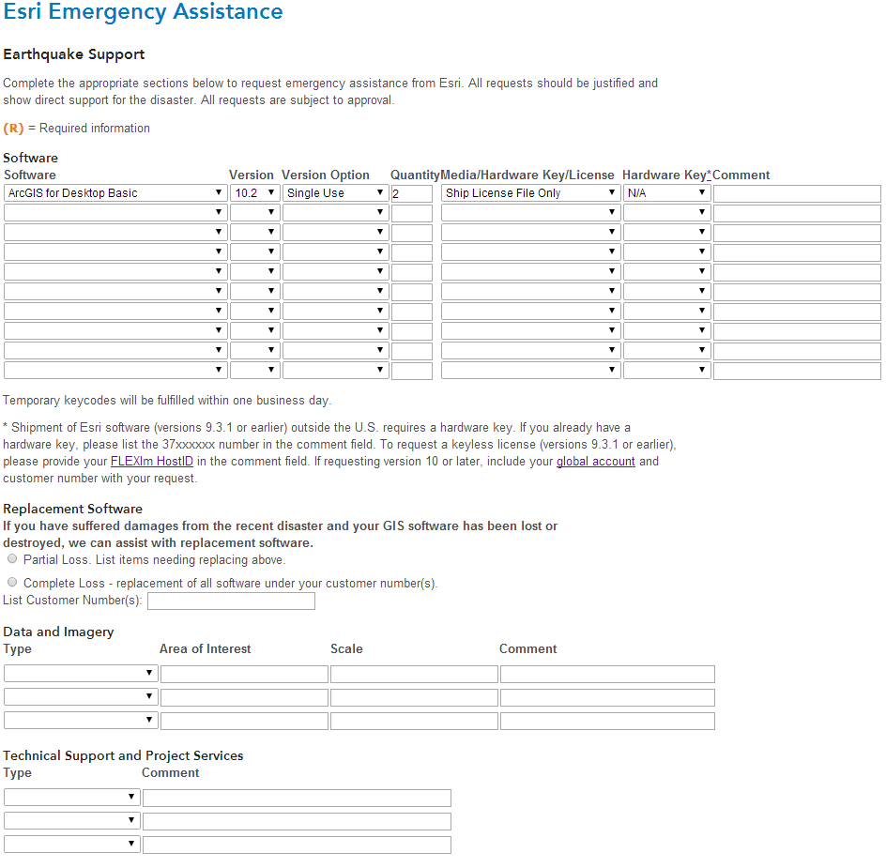

Requesting License for OCHA Staff Members Deploying Under Emergency Response Roster (ERR)

ERR members may request ArcGIS license by contacting FIS field support focal points. If the deploying staff member already has an ESRI Global Account, he/she may immediately initiate a request through [ESRI’s emergency assistance site](http://www.esri.com/services/disaster-response/earthquakes) as described above. The staff member must also inform FIS about the initiated request.

Requesting License for OCHA Staff Members Working In Their Own Duty Station

Staff members working in their own duty station must initially get in touch with to obtain ArcGIS licenses under ESRI’s DRP.

Requesting License for Stand-by Partners with OCHA Computer

ArcGIS licenses for Stand-by Partners deploying with a standard OCHA computer may be requested through FIS field support focal points. Once the standard OCHA computer has been provided by CIS, the ArcGIS software will be installed by FIS.

Requesting License for Stand-by Partners with Personal Computer

ArcGIS licenses for Stand-by Partners deploying with a personal computer may be requested through FIS field support focal points. CIS and FIS hold no responsibility in installing ArcGIS software using DRP license on a personal computer.

ESRI Products References

* Full list of ESR Products: <http://www.esri.com/products>
* ArcGIS for Desktop: <http://www.esri.com/software/arcgis/arcgis-for-desktop>
* ArcGIS Online: <http://www.esri.com/software/arcgis/arcgisonline>
* ArcGIS for Server: <http://www.esri.com/software/arcgis/arcgisserver>