USER GUIDE - ArcGIS Pro
OCHA Reference Map Template
As of 07 July 2022
This user guide has guiding steps on how to use and customize the Reference Map Template to your needs. Furthermore, it contains links to useful resources.

What is in the project package
The 2022_OCHA_RefMap_Template_ArcPro2.9 project package (.ppkx) contains maps, layouts, database, styles, server connection used to create the reference maps and this user guide as an attachment.
- Maps: include all the globes and base maps of different size and orientation
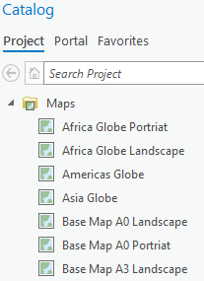
- Databases: include the geodatabase with the different feature datasets used in the reference maps
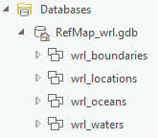
- Layouts: here you will see reference maps in portrait and landscape layouts for A4, A3 and A0 size
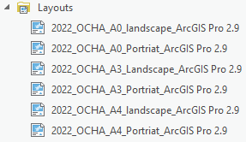 | 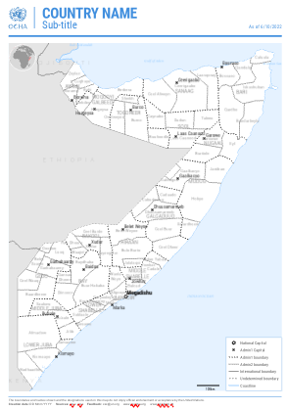 | 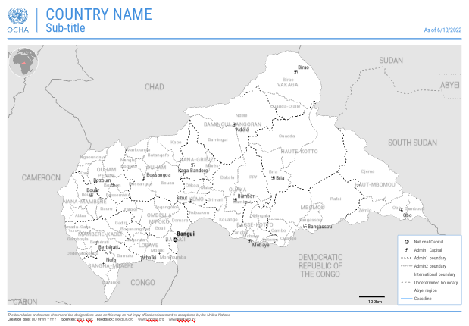

- Styles: contains the default styles and imported OCHA styles
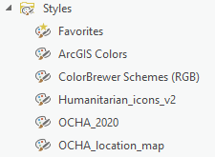
- Servers: include ITOS COD live services, for countries with an alternate edge-matched COD-AB version, check the COD_External_Egematch folder
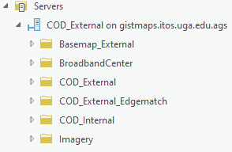

Steps
- Change the featured layer data source path to your country of interest – single layer source
- This step can be done both from the map frame or layout. Select the layout where you want to work with
- From the Contents pane, right-click on the layer you want to change, go to Properties
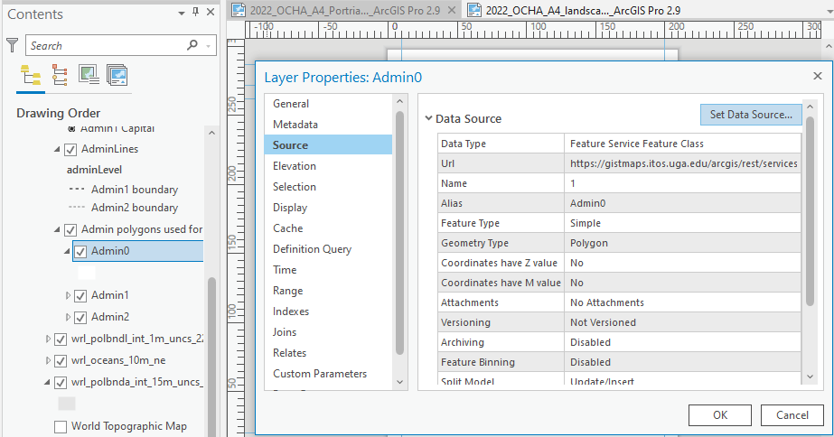
- From the Layer Properties pane, click on Source and click on Set Data Source button

- From the Change data source pane, under Projects > Servers > COD_External and select the country of your interest (ISO 3 country code)

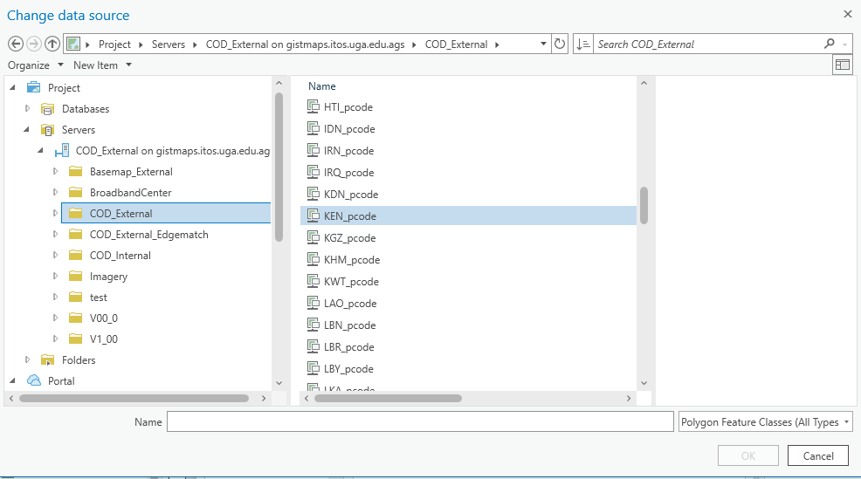
- Select the respective admin layer and click Ok.

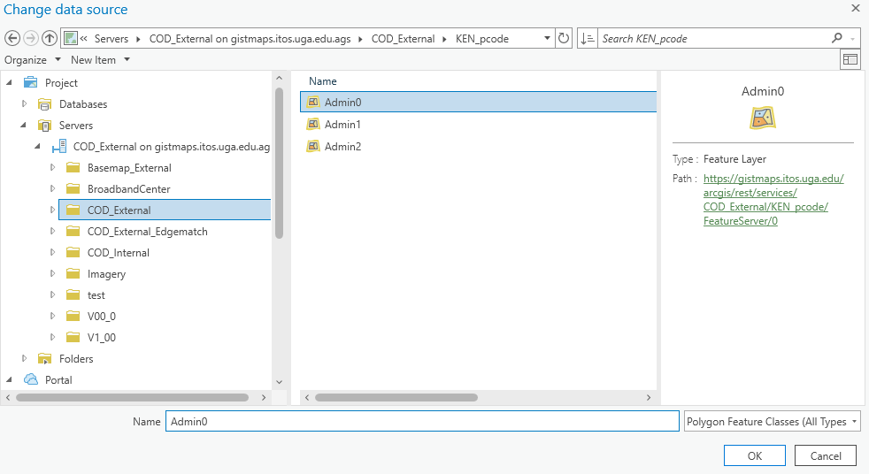
- Once the source is changed, go to the Contents pane, right-click on the same layer and Zoom to Layer to see the change on your map and layout

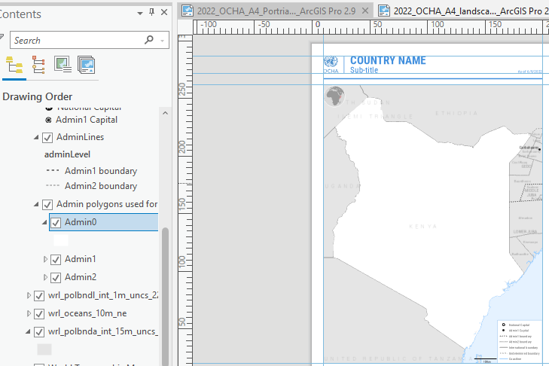

- Change the featured layer data source path to your country of interest – multiple layers source at one time
- From the ribbon (interface menu) go to View > Catalog View.
- From the Catalog View, double click on Maps to see list of maps
- Click on the map that contains the layers you want to change

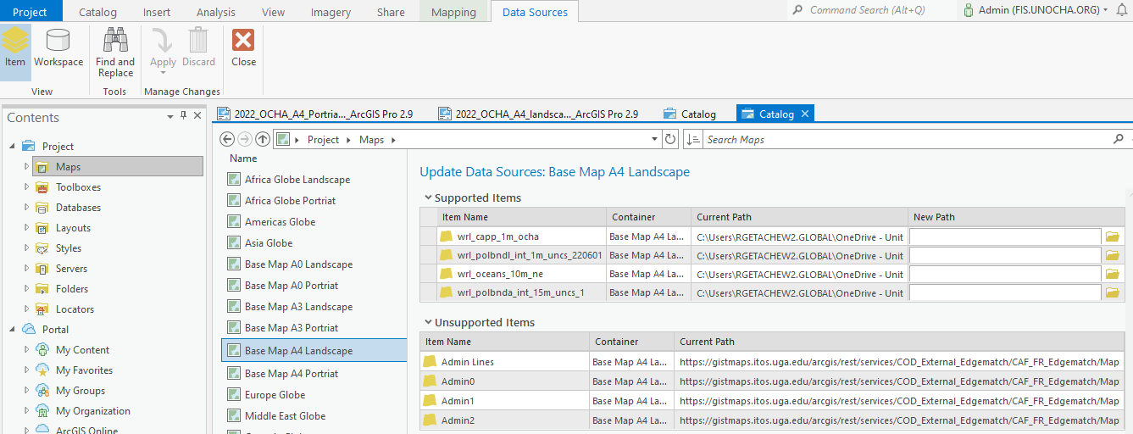
In the pane above you see items coming from the Database (Supported Items) and those coming from Server (Unsupported Items)
- Click on Data Sources ribbon and go to Find and Replace tool
- Select all the layers under Supported Items list and provide the old geodatabase path and the current geodatabase folder path on the Find and Replace pane respectively
- Click on the double arrow to Replace all matches
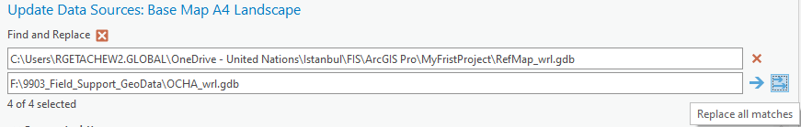
- Click on the drop-down arrow on Apply tool, next to the Find and Replace > Validate and Apply to validate the changes you are making
- Click Close to close the data source path editing session
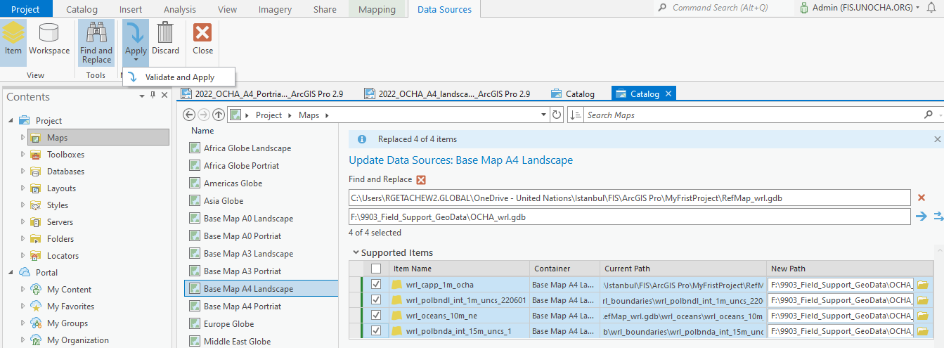

- Add existing data to your map from local folder connection
Let’s say you want to add road data from your dataset to the A3 reference map. You can do it by clicking on the Add Data tab from the Map ribbon or through folder connection with the folder that contains the road data.
- From Catalog pane right-click on Folders > Add Folder Connection, navigate to your folder and click ok
- Now the folder connection is created drag and drop your road data to the Contents pane to add it
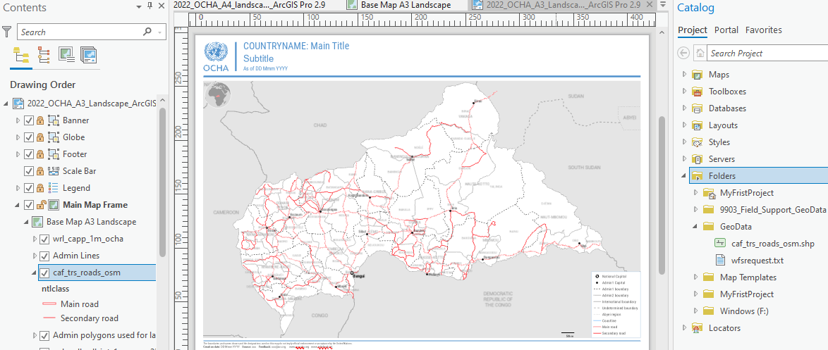

- Import your existing ArcMap document to this project file
There are two ways to import your existing .mxd file to this project file. A) From Insert ribbon > Import Map tab or B) From Catalog pane > Folders go to your mxd file, right-click Import and Open
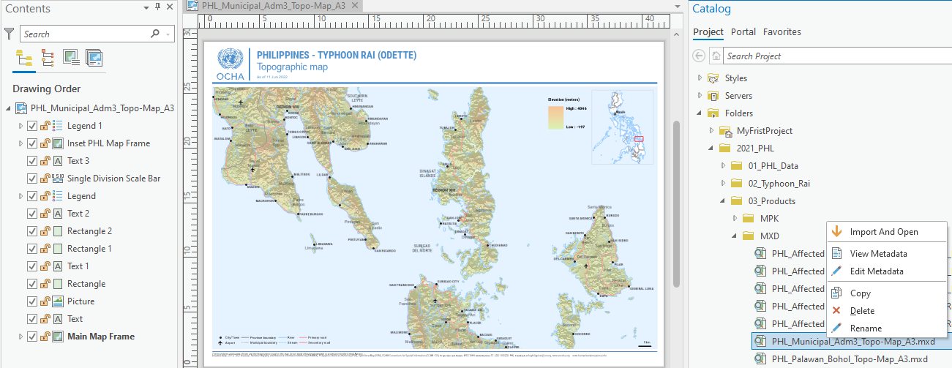

Resources
- How to import existing ArcMap documents to ArcGIS Pro
- Migrating to ArcGIS Pro from ArcMap (requires to login My Esri with public account)
- Project Templates
- Save a copy of the current project file with a new name - if you want to work on different thematic map other than reference map but you want to keep the layout elements (Banner, Globe, Footer, scale bar etc.) same

