Note: an IM strategy will need to adapt throughout an emergency. Below is just a capture of the IM strategy in the Philippines on 21-Dec. It looked different a few weeks before and had changed a month later.

Information Management Strategy
Typhoon Yolanda
21 December 2013

Background to Emergency
Big typhoon destroyed a large swath of the Philippines. If you want to know more, read the Sit Reps.

Previous Version of Strategy Doc
Given the strategy within an emergency must adapt and this Google Doc is a living version, copies will be made occasionally to show the changes over time.
- 10-December version

Information Management Approach (Predictability)

Many of the problems or challenges that we face in emergency information management are human-related problems. Yet, we often try to solve them with technical tools. In the early phases of this emergency, OCHA setup simple every-day collaborative tools with the clusters and did so in way that lended to clear operating procedures. These are outlined in the following sections.

Information Management Reporting Cycle

In order to make OCHA’s Information Management activities predictable to our partners and clients as well as significantly reduce the ad-hoc craziness that often ensues in the IM world, OCHA IM has setup a standard IM reporting and product cycle. By using this approach, we give the clusters space to do their work between reporting periods and allow them to be predictable with their cluster members (as they define a reporting cycle for their members). Having predictable products also calmed down management’s demand for products as they always know when the next one would come. Figure 1 show the reporting cycle defined about one month of the emergency with a focus on 3W data.

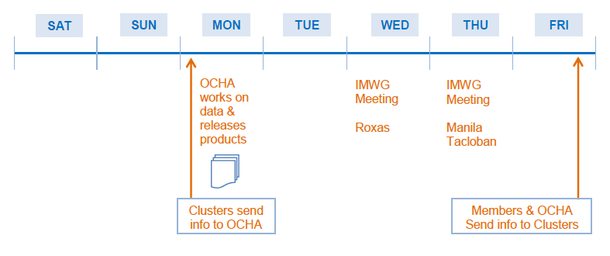
Figure 1: Information Management Reporting Cycle

Information Management Data Flow

Given the geographical spread of the emergency and the multiple coordination hubs, an IM data flow needed to be agreed upon early in the emergency. In order to provide clarity, it was decided (with the clusters) that the field clusters would be responsible for collecting their own local data, sharing it with Manila clusters who compile it, and then the data would be shared with OCHA on dropbox (which means both OCHA Manila and Field get access). With this approach, products can be generated anywhere along the chain of data movement. See Figure 2 for a visual depiction of the setup.

Of course, we know that OCHA will continue to receive data from partners who visit the reception centers, people who attend meetings, and by email. The agreed approach with the clusters was that OCHA would happily accept this data, but then pass along to the cluster (as the respective level) for incorporation into their 3W data. In this arrangement, OCHA becomes an extra conduit of information for the clusters.

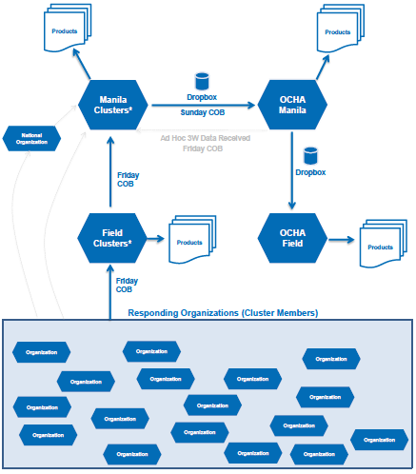
Figure 2: Information Management Data Flow

Collaboration and Tools

With the increased used of modern collaboration tools, especially their regular use within OCHA on a day-to-day basis, the below tools were used to improve collaboration and data flow within the emergency.

- OCHA Philippines IMO Skype group: a private Skype group was setup for all OCHA IM (and Assessment Officers) responding to the emergency. This group gives us the secure space to talk about the emergency, challenges we are facing, and plans moving forward.
- Yolanda IM Skype group: a Skype group composed of all the IM responders to the emergency. Although the focus was on ensure the cluster IMOs were present in the group, it is not exclusive to just clusters.
  - This group helped to build a “community” atmosphere within the IMOs. Often we have found IMOs from different clusters and different locations helping each other. It has helped bring a team attitude to much of the group. Several cluster IMOs have expressed their appreciation of this group.
  - This Skype group really complemented the in-person IMWG meetings and actually can be seen as the virtual version of an IMWG in an emergency.
- Structured Dropbox: a dropbox folder was set up where all cluster IMOs were invited. Careful structuring was applied to ensure that clusters knew where they could place and/or edit data. There was no attempt to have shared working files.
  - Only two cases of files being deleted have been encountered. In both cases, we simply restored the files using Dropbox.com interface.
- SkyDrive for Figures: a SkyDrive based XLS file was created by Christian Cricboom (ROWCA) which is now managed by Joseph Addawe. Being able to easily update and XLS file and then have it embedded into the HR.info has made providing authoritiative figures much easier.
- Google Docs for 3W raw data: although we did 3W heavy-lifting in XLS, we then made the data openly available by uploading it to Google documents. Without a tool to upload and share such data, Google Docs provided a quick and easy solution. This open data was then used by external groups (e.g. British Red Cross) to create products.
- Assessment Registry: we did not want yet another emergency to pass where very few assessments were captured. By leveraging the Assessment Registry on HR.info and collecting as many assessments as possible, including efforts by remote volunteers, we have put together the most comprehensive list of assessments ever seen in emergency of this size (attributed to DFID). Great efforts were made by the HR.info developers to map the assessments online as well as expose the data for offline, static map creation.
- HR.info Platform: Thanks to an already existing HR.info country site and the favorable context of the Philippines in terms of connectivity and open information, we were able to scale the use of the HR.info platform up and to exploit it core features (e.g. contact directory, meeting schedule) to the fullest. While during the first 10-14 days OCHA populated the site with all information it could find, cluster IMOs quickly stepped in and made use of the platform to coordinate among cluster members and to share their information products with the broader humanitarian community. Due to high staff turnover within the agencies, the challenge will continuously remain to familiarize incoming responders with the platform. IMOs in the different coordination hubs play a crucial role in sensitizing cluster members and encouraging Cluster IMOs to populate the site.
  - HR.info training: during the month of January, it is expected that one OCHA IMO will visit each of the coordination hubs to provide training on HR.info to new OCHA IM staff, new cluster IM staff, and new OCHA national staff.

Operational Advocacy

In order to ensure that a wide audience of people could be exposed to the content being added to the HR.info, the OCHA IM team undertook strategic “operational advocacy” efforts using MailChimp. So far, sharing the information, changes, capabilities and materials of HR.info through the MailChimp tool, many in the field, donors and HQ are much more well versed in information available and the capabilities of HR.info. Anecdotal feedback from people like the CRD desk officer, FIS-GVA, in-country donors, and many in-country responder has been very positive. Each MailChimp distribution has been crafted to in engaging language and include a clever sign-off. It should be noted that several people have noted on the refreshing writing style and reading to the end to see what the sign-off would be.

Moving forward in the Philippines, this approach should continue albeit with a lower frequency. Throughout the month of January, we should aim to distribute at least twice per week. After January, the frequency should be re-evaluated.

Data:

Great efforts have been made during the early weeks to update and manage the Common Operational Datasets. Partners both in and out-of-country have been quite appreciative of the CODs. One minor exception was the result of a mis-understanding in WHO.

As the efforts and quality of the CODs have matured over the past few years, we were able to get these dataset prepared very quickly and have many partners ready to use them. Thus the focus in this emergency quickly began morphing into a Fundamental Operational Dataset discussion. As the general demands on OCHA begin to decrease, we should use any excess capacity to aid in getting as many FODs released including the collaboration with non-traditional partners (e.g. HOT). This effort would be a strategic benefit well beyond this emergency.

A common request from clusters and partners has been to help get data from the Government. Using a variety of contacts, OCHA has facilitated the submissions of “wish lists” to the government through multiple channels. Although the clusters will need to push on their government counterparts for FOD-related data, OCHA will continue to push centrally for such data and help facilitate discussions wherever possible.

OCHA has been and will continue compiling and making data available in three locations:
- COD/FOD website
- Dropbox folder for private data
- HR.info Philippines site

Assessment Support

With WFP taking the technical lead for both MIRA I and MIRA II, OCHA IM support requirements to these activities have been limited. Our focus was on ensuring core data was ready to enable analysis and ensuring as many assessments were available in the Assessment Registry as possible (for secondary analysis). Going forward, our focus will continue to be in ensuring the Assessment Registry is up-to-date.

SRP Support

The OCHA IM team provided support to the SRP process in the following areas:
- Initial review of cluster indicators to outline feasibility so that constructive criticism could be given back to the clusters.
- Significant work on trying to develop some form of data-verifiable “in-need” number for the SRP. Multiple models were provided to the SRP team.
- Mapping of planned projects and a simple infographic on funding requirements by cluster.

Efforts related to the SRP will be related to monitoring (see below) of the indicators defined by the clusters.

Monitoring

Although the Assessment/Monitoring Working group will be the main entity to deal with Monitoring, IM has been and will continue to be involved.

To date, the IM team has been working with the cluster IMOs to ensure they define better indicators and have had IMWG-level discussions about how data will be collected to answer a variety of indicators. Within the IMWG, the group has discussed the proposed reporting cycle so that the IMOs start to think about the data collection requirements.

The IM team is expected to provide the technical solution to both collect and then store/analyze the monitoring inputs. No concrete steps have been taking to-date as not agreement on level of monitoring has yet been agreed. Once agreed, the IM team will work to develop a data collection tool, a storage location for the data, and a variety of graphic outputs to show results over time.

Products & Product Catalogue

In order to be predictable, OCHA needs to defined the various products that it expects to produce in 2014. Not only will this make us predictable to audiences about when products will be released, but it will also make us more predictable about when we will request information from our partners.

Once defined, we will need to produce a 2014 calendar showing data collection points and product release dates. We will also create a product catalogue to outline and explain each core product.

Product Processes

As we move forward and products become a bit more predictable, we need to begin defining the steps and process to develop the said products. One developing example is the 3W - data process. Not only will these help in this emergency, especially with staff turnover, but they can be used outside the emergency to begin developing standard guidance for future responders.

Field IM?
Should we add a dedicated section (or a section per coordination hub)?

- what about how we support the field?

- what about products created for field needs?

- should we outline standard field requirements?

Drafted 21 December 2013
Andrej Verity

